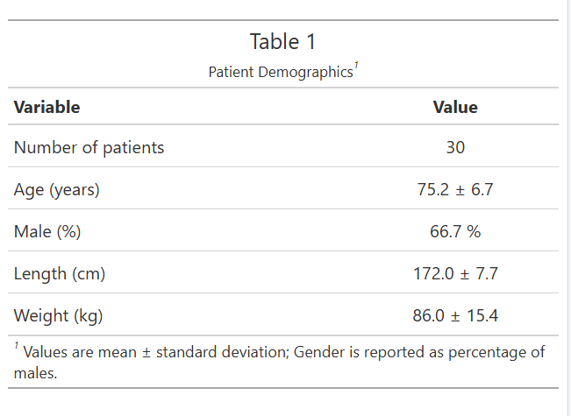

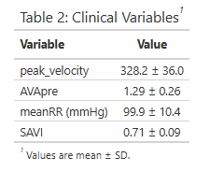
Normality check, not normally distributed:

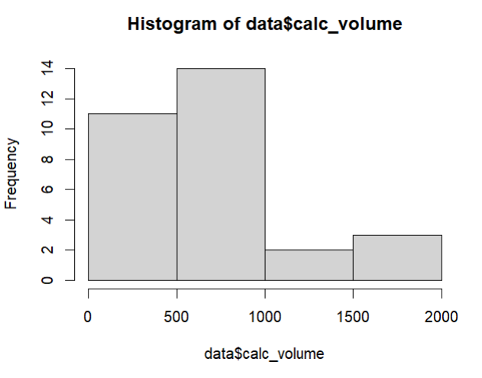
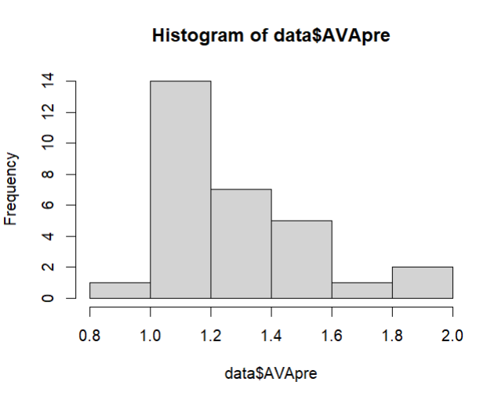
- Calc_volume
- NCC_calc
- LCC_calc
- RCC_calc
- AVApre – right skewed, large AVAs

correlation between variables:
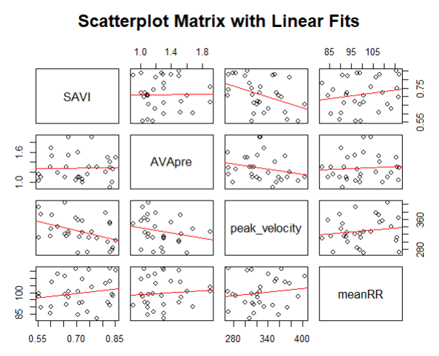

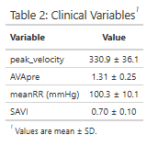

Gender comparison
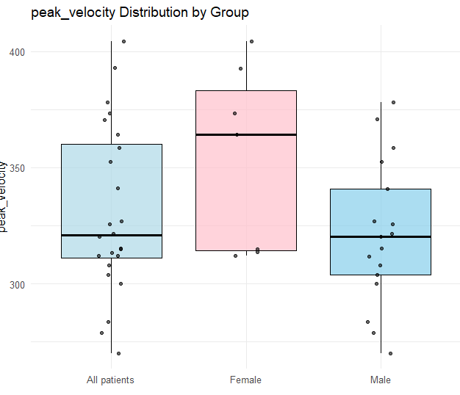
Difference peak velocity is significant, p = 0.04

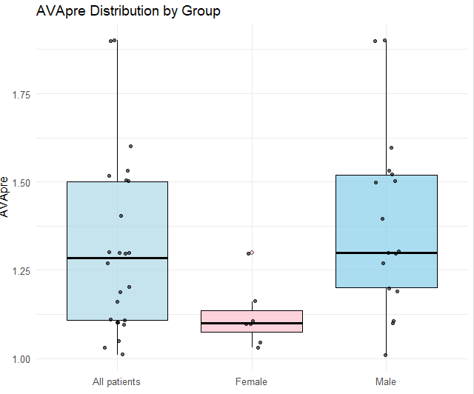
Difference AVA is significant, p = 0.01

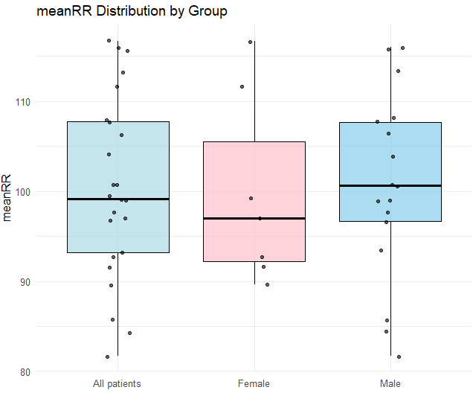
Difference meanRR not signficant

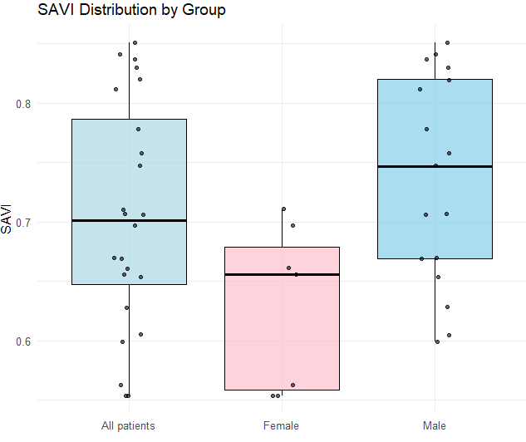
Difference is significant, p = 0.008

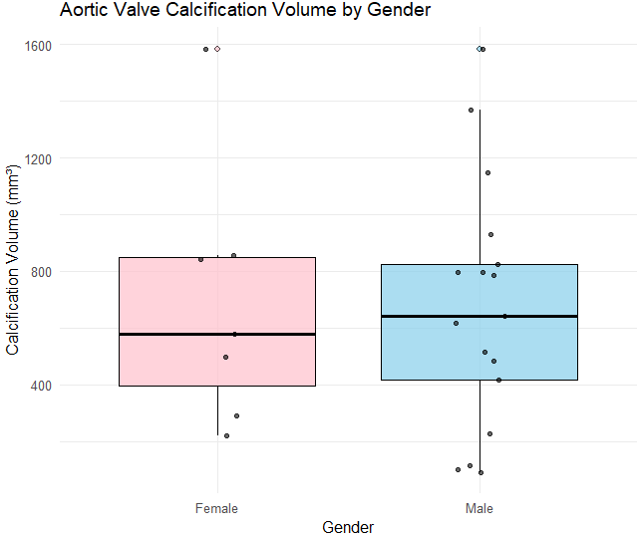

Difference AVC not significant (p=0.9)

OVERALL CALCIFICATION

Correlational tests:
- Only correlation between SAVI and overall AVC (p = 0.03)
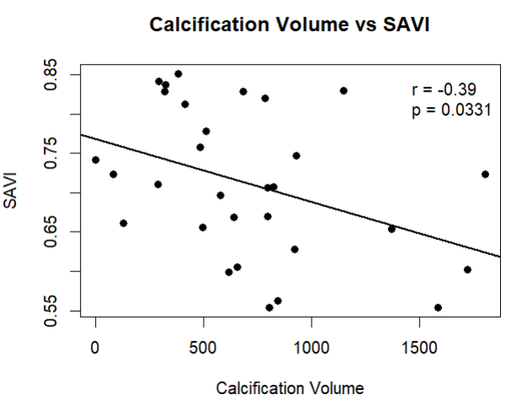

LEAFLET-SPECIFIC CALCIFICATION
Normality check:
- LCC and RCC not normally distributed -> use spearman instead of pearson

Using the friedman test: calcification between cusps is statistically different from 0
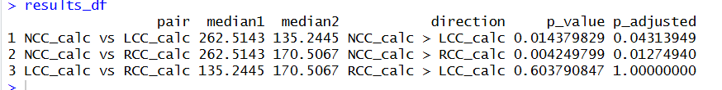

NCC_calc is higher than both
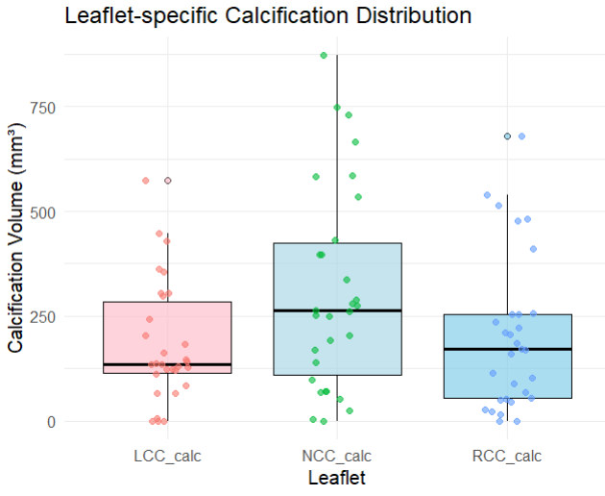

- SAVI - Leaflet-specific

Significant relationship between SAVI and NCC_calc

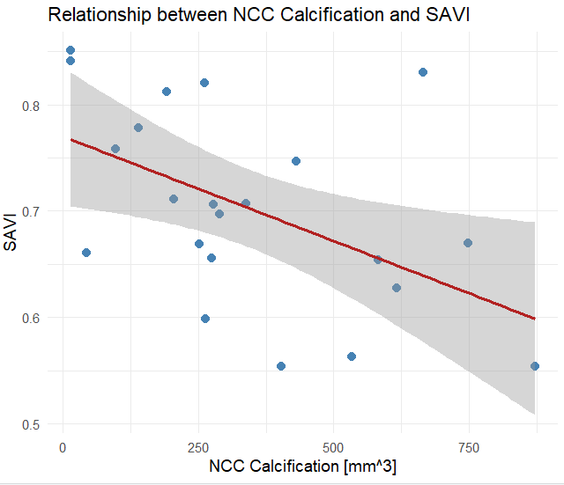

REGRESSION MODEL TO TEST LEAFLET-SPECIFIC INFLUENCE FOR SAVI
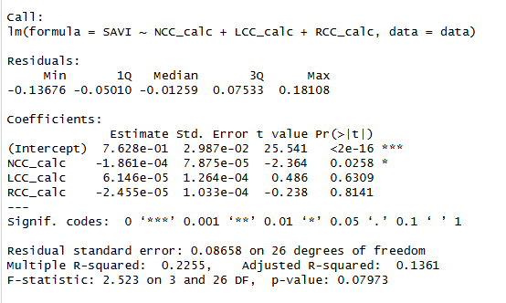

NCC_calc significant in the context other leaflets
- Multicollinearity is not problematic as checked with vif

- AVA – Leaflet-specific
No significant correlational effect
Model not statistically significant, low F-value
No multicollinearity

- PEAK VELOCITY - Leaflet-specific
Significant correlational effect between peak_velocity and RCC_calc (p= 0.015)
Model not statistically significant

- MEAN GRADIENT - Leaflet-specific
No significant correlational effect
Model not statistically signficiant

CENTRAL vs. PERIPEPHERAL ANALYSIS

Normality check;
- peripheral total calc is normally distributed and total central calc is not normally distributed, p = 0.02.

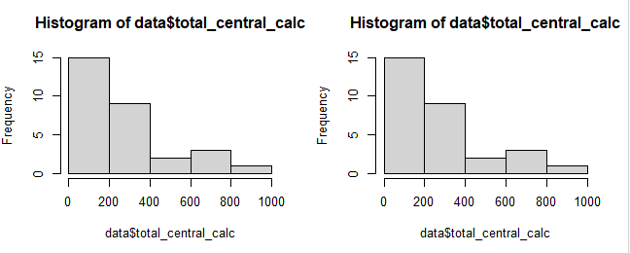

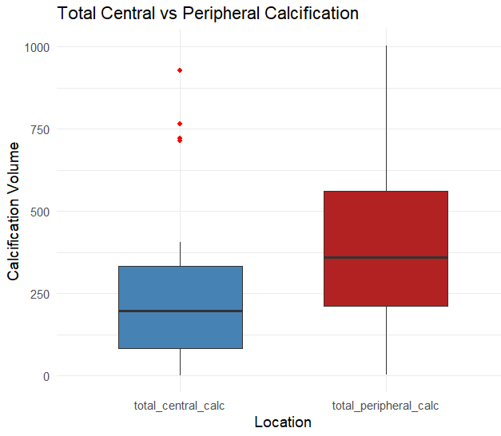

Wilcox rank test points out that the difference is not significant

- SAVI – Central vs. Peripheral
Correlational test – Statistical relationship between totalcentral calc and the SAVI!! (p = 0.03)
Linear model not significant

- AVA - Central vs. Peripheral
Correlational test not significant
Linear model not significant

- – Mean gradient – Cetnral vs. Peripheral
Correlational test not significant
Linear model not significant

- Peak velocity – Central vs. Peripheral
Correlational test not significant
Linear model not signficiant

WITHIN LEAFLET ANALYSIS

Normality check:
- Cental RCC calc is not normal
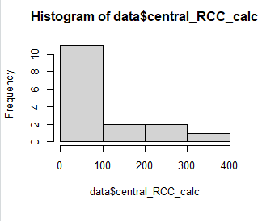
- Peripheral_LCC_calc not normal
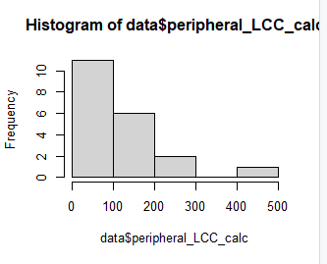

Correlation between regions: Peripheral_LCC and peripheral NCC have high correlation

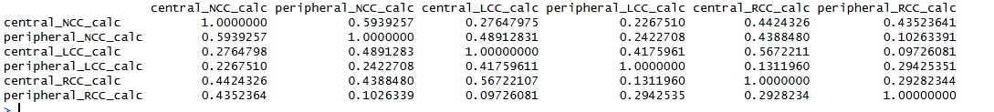

• NCC central vs peripheral: 0.59
• LCC central vs peripheral: 0.42
• RCC central vs peripheral: 0.29

• LCC central ↔ RCC central: 0.57
• NCC central ↔ RCC central: 0.44
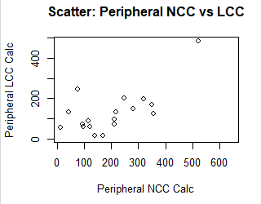

Looking at how the calcium is distributed amongst patients:
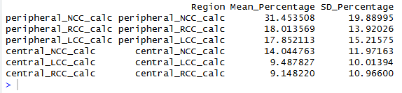

- SAVI
LM not significant
No correlational tests were significant

For all severity parameters:
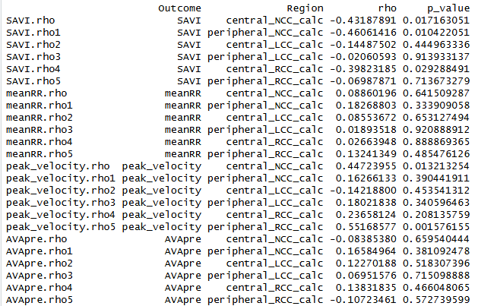

- SAVI
- • central_NCC_calc → ρ = -0.43, p = 0.017
- • peripheral_NCC_calc → ρ = -0.46, p = 0.010
- • central_RCC_calc → ρ = -0.40, p = 0.029

PEAK VELOCITY
• central_NCC_calc → ρ = +0.45, p = 0.013
• peripheral_RCC_calc → ρ = +0.55, p = 0.0016 ← strongest in your whole table

MEANRR
Nothing

AVApre
Nothing
Linear models:
- Non significant for peak_velocity
- Non significant for meanRR
- Non significant for AVApre
- Non-significant SAVI

